Week-6 (DAY-28,29) Hands-On – Keerthivasan R
Problem: Contact Management Web Application
Scenario:
ABC Infotech wants to develop a mini web application using ASP.NET Core MVC to manage contact persons of their clients. The system should allow users to add new contacts, view all contacts, and search for a specific contact by ID. The goal is to build a simple, user-friendly application without using a database, suitable for initial development and learning purposes.
Requirements:
1.Add Model class ContactInfo with auto implemented properties:
Name | Type | Modifier
ContactId | int | Public
FirstName | string | Public
LastName | string | public
CompanyName | string | public
EmailId | string | public
MobiliNo | long | public
Designation | string | public

2.Add ContactController class and declare variable and write action methods given below.
Declare variable- static List<ContactInfo> to collect and maintain contact details.
Functions | Description
public ActionResult ShowContacts() | This action methods send object of type List<ContactInfo> to view and displays contact details in tabular format on view.
public ActionResult GetContactById(int id) | This action method takes id as input and search contact detail using ContactId and send that object of type ContactInfo to view to show contact details.
public ActionResult AddContact() | This action method returns a view to accept contact details from user to add new contact into List<ContactInfo>.
[HttpPost]  public ActionResult AddContact(ContactInfo contactInfo) | This action invokes when user click Save button added into above view after entered new contact details. Add new contact details object into a List<ContactInfo> and show all the contact in tabular format by redirecting to ShowContacts.

3. Set ContactInfoController and ShowContacts action method on start-up and run the project.
Technical Constraints
- Use ASP.NET Core MVC (.NET 8 or above)
- Follow MVC Architecture (Model-View-Controller)
- Use strongly typed views
- Use Model Binding for POST requests
- Use LINQ for searching data
- Do NOT use any database (in-memory list only)
Expectations
- Application should run successfully without errors
- Users should be able to:
  - Add new contact
  - View all contacts
  - Search contact by ID
- Proper separation of concerns (MVC pattern)
- Clean and user-friendly UI
- Proper data flow between Controller and View
Learning Outcome
- Understand ASP.NET Core MVC architecture
- Learn how to create and use models, views, and controllers
- Understand form handling (GET & POST)
- Learn model binding and data passing
- Practice LINQ for data filtering
- Understand routing and application flow
- Build a complete mini end-to-end MVC application
CODE:
Models/ ContactInfo.cs
using System.ComponentModel.DataAnnotations;

namespace ContactApp.Models
{
public class ContactInfo
{
[Required(ErrorMessage = "Contact ID is required")]
public int ContactId { get; set; }

[Required(ErrorMessage = "First Name cannot be empty")]
public string FirstName { get; set; }

[Required(ErrorMessage = "Last Name is required")]
public string LastName { get; set; }

public string CompanyName { get; set; } // Optional field

[Required(ErrorMessage = "Email is required")]
[EmailAddress(ErrorMessage = "Invalid Email Address")]
public string EmailId { get; set; }

[Required(ErrorMessage = "Mobile Number is required")]
public long MobileNo { get; set; }

public string Designation { get; set; }
}
}

Controllers/ ContactController.cs
using ContactApp.Models;
using Microsoft.AspNetCore.Mvc;

namespace ContactApp.Controllers
{
public class ContactController : Controller
{
// In memory list
private static List<ContactInfo> contacts = new List<ContactInfo>
{
new ContactInfo { ContactId = 1, FirstName = "Sakshi", LastName = "Jadhav", CompanyName = "Cognizant", EmailId = "sakshi@gmail.com", MobileNo = 8765463534, Designation = "Software Engineer" },
new ContactInfo { ContactId = 2, FirstName = "Mahi", LastName = "Reddy", CompanyName = "Capgemini", EmailId = "mahi@gmail.com", MobileNo = 9876764337, Designation = "Frontend Developer" }
};

// SHOW ALL CONTACTS
public ActionResult ShowContacts()
{
return View(contacts);
}

// GET CONTACT BY ID
public ActionResult GetContactById(int id)
{
var contact = contacts.FirstOrDefault(c => c.ContactId == id);
if (contact == null)
{
return Content("Contact Not found!");
}
return View(contact);
}

// LOAD ADD CONTACT PAGE
public ActionResult AddContact()
{
return View();
}

// SAVE CONTACT
[HttpPost]
[ValidateAntiForgeryToken]
public ActionResult AddContact(ContactInfo contact)
{
if (ModelState.IsValid)
{
// Check if ID already exists (since we don't have a DB to handle unique keys)
if (contacts.Any(c => c.ContactId == contact.ContactId))
{
ModelState.AddModelError("ContactId", "This ID is already taken!");
return View(contact);
}

contacts.Add(contact);
return RedirectToAction("ShowContacts");
}
return View(contact);
}
}
}

Views/ Contact/ AddContact.cshtml
@model ContactApp.Models.ContactInfo

<h2>Add New Contact</h2>

<div asp-validation-summary="ModelOnly" class="text-danger"></div>

<form asp-action="AddContact" method="post">

<div class="mb-3">
<label asp-for="ContactId"></label>
<input asp-for="ContactId" class="form-control" />
<span asp-validation-for="ContactId" class="text-danger"></span>
</div>

<div class="mb-3">
<label asp-for="FirstName"></label>
<input asp-for="FirstName" class="form-control" />
<span asp-validation-for="FirstName" class="text-danger"></span>
</div>

<div class="mb-3">
<label asp-for="LastName"></label>
<input asp-for="LastName" class="form-control" />
<span asp-validation-for="LastName" class="text-danger"></span>
</div>

<div class="mb-3">
<label asp-for="CompanyName"></label>
<input asp-for="CompanyName" class="form-control" />
<span asp-validation-for="CompanyName" class="text-danger"></span>
</div>

<div class="mb-3">
<label asp-for="EmailId"></label>
<input asp-for="EmailId" class="form-control" />
<span asp-validation-for="EmailId" class="text-danger"></span>
</div>

<div class="mb-3">
<label asp-for="MobileNo"></label>
<input asp-for="MobileNo" class="form-control" />
<span asp-validation-for="MobileNo" class="text-danger"></span>
</div>

<div class="mb-3">
<label asp-for="Designation"></label>
<input asp-for="Designation" class="form-control" />
<span asp-validation-for="Designation" class="text-danger"></span>
</div>

<button type="submit" class="btn btn-primary">Save Contact</button>
</form>

@section Scripts {
@{
await Html.RenderPartialAsync("_ValidationScriptsPartial");
}
}
Views/ Contact/ GetContactById.cshtml
@model ContactApp.Models.ContactInfo

<h2>Contact Details</h2>
<div class="card p-3">
<p><strong>ID:</strong> @Model.ContactId</p>
<p><strong>Name:</strong> @Model.FirstName @Model.LastName</p>
<p><strong>Company:</strong> @Model.CompanyName</p>
<p><strong>Email:</strong> @Model.EmailId</p>
</div>
<a asp-action="ShowContacts">Back to List</a>
Views/ Contact/ ShowContacts.cshtml
@model IEnumerable<ContactApp.Models.ContactInfo>

<h2 class="mt-3">Client Contact List</h2>

<div class="mb-3">
<a asp-action="AddContact" class="btn btn-primary">Add New Contact</a>

<button onclick="searchById()" class="btn btn-secondary">Search Contact</button>
</div>

<table class="table table-bordered table-striped">
<thead class="table-dark">
<tr>
<th>ID</th>
<th>First Name</th>
<th>Last Name</th>
<th>Company</th>
<th>Email</th>
<th>Mobile</th>
<th>Designation</th>
<th>Action</th>
</tr>
</thead>
<tbody>
@if (Model != null && Model.Any())
{
@foreach (var item in Model)
{
<tr>
<td>@item.ContactId</td>
<td>@item.FirstName</td>
<td>@item.LastName</td>
<td>@item.CompanyName</td>
<td>@item.EmailId</td>
<td>@item.MobileNo</td>
<td>@item.Designation</td>
<td>
<a asp-action="GetContactById" asp-route-id="@item.ContactId" class="btn btn-sm btn-info">Details</a>
</td>
</tr>
}
}
else
{
<tr>
<td colspan="8" class="text-center text-muted">No contacts found in the list.</td>
</tr>
}
</tbody>
</table>

@section Scripts {
<script>
function searchById() {
// 1. Ask user for the ID
var id = prompt("Enter Contact ID to search:");

// 2. If user didn't hit cancel and entered a value
if (id && id.trim() !== "") {
// 3. Redirect to the GetContactById action in the Contact controller
window.location.href = "/Contact/GetContactById/" + id;
}
}
</script>
}

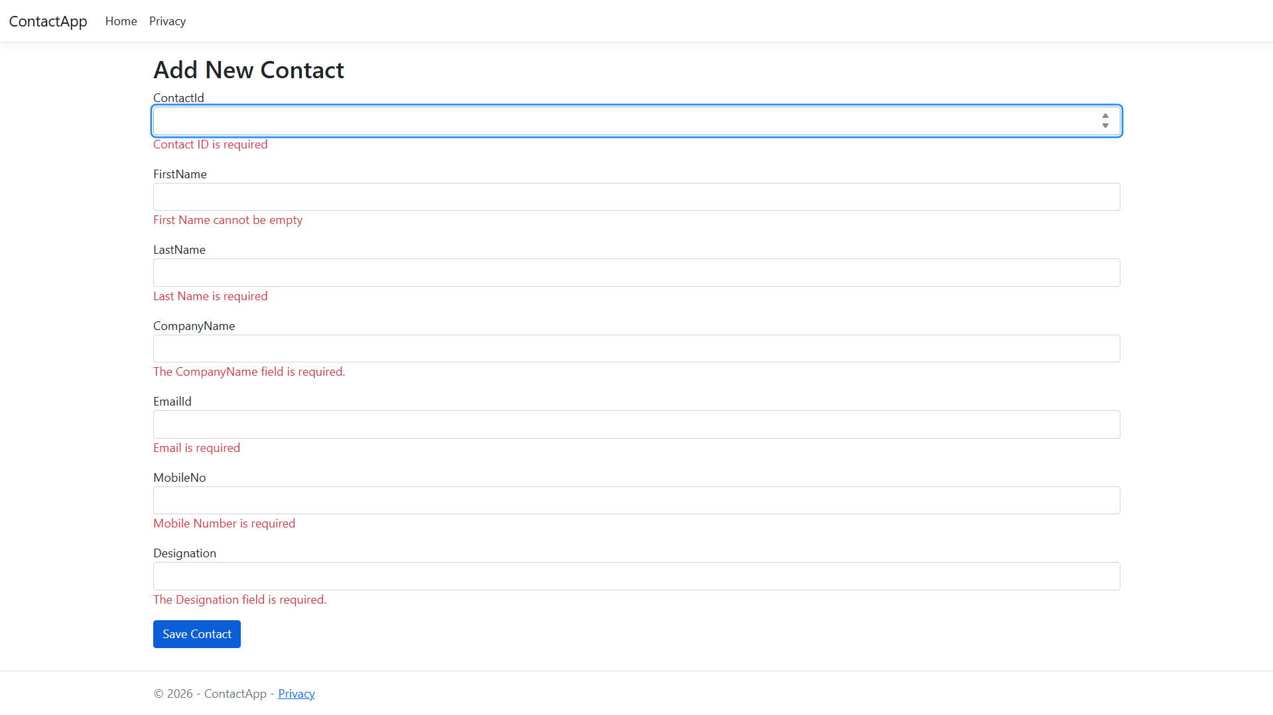
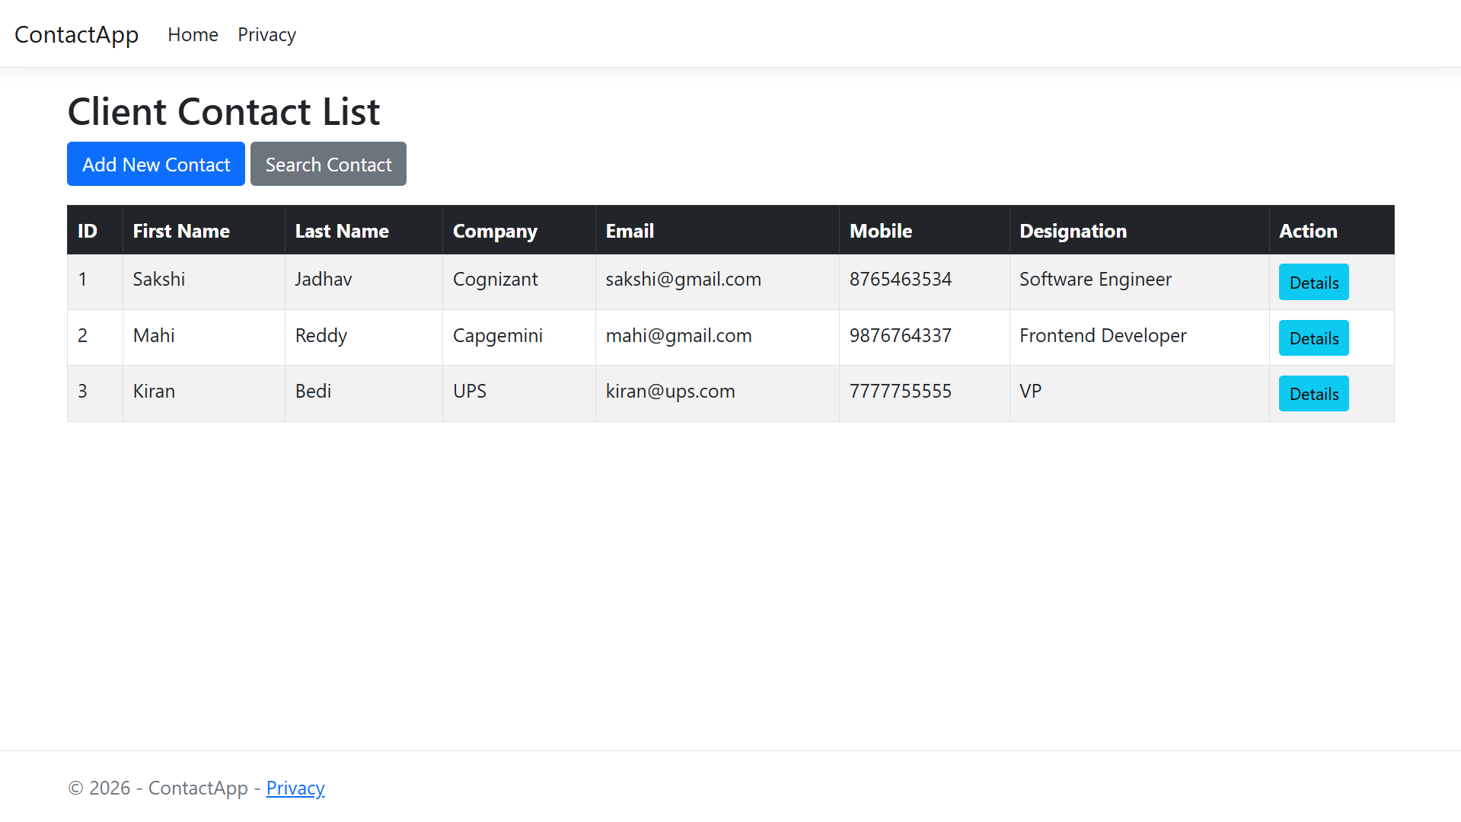
OUTPUT:

